To standard matrix or not to standard matrix:

Here are the options:

* I am using a larva as my system and I would like to produce a percent recovery.
* My project is looking at the lipid differences between 4 phenotypes.
* I was thinking to take *n* larvae from each phenotype, pooling them into one large sample, and then adding a known concentration of lipid to them.
* I have 4 phenotypes that I am testing and I am curious if there is a need to include all 4 phenotypes in the creation of my standard matrix?

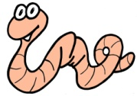

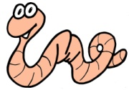 *nx*: (from each of the 4 phenotype)

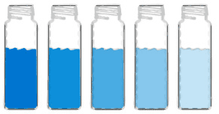



Extract Pooled Larvae

50% of sample gets spiked

50% of sample without spike

% of recovered lipids